Task :

// C++ code

//

void setup()

{

pinMode(13, INPUT);

pinMode(9, OUTPUT);

pinMode(10, OUTPUT);

pinMode(8, OUTPUT);

pinMode(12, OUTPUT);

pinMode(6, OUTPUT);

pinMode(11, OUTPUT);

}

void loop()

{

int potValue=analogRead(A0); // to read the potentmetr value

int pwmEn=map(potValue,0,1023,0,255);

analogWrite(9,pwmEn); // we send the pwm to the en pins

analogWrite(10,pwmEn);

if (digitalRead(13)==HIGH) //Move the motor forward

{ digitalWrite(12,1);

digitalWrite(8,1);

digitalWrite(11,0);

digitalWrite(6,0); }

else //Move the motor backwards

{ digitalWrite(12,0);

digitalWrite(8,0);

digitalWrite(11,1);

digitalWrite(6,1);

}

delay(150); // Wait for 150 millisecond(s)

}

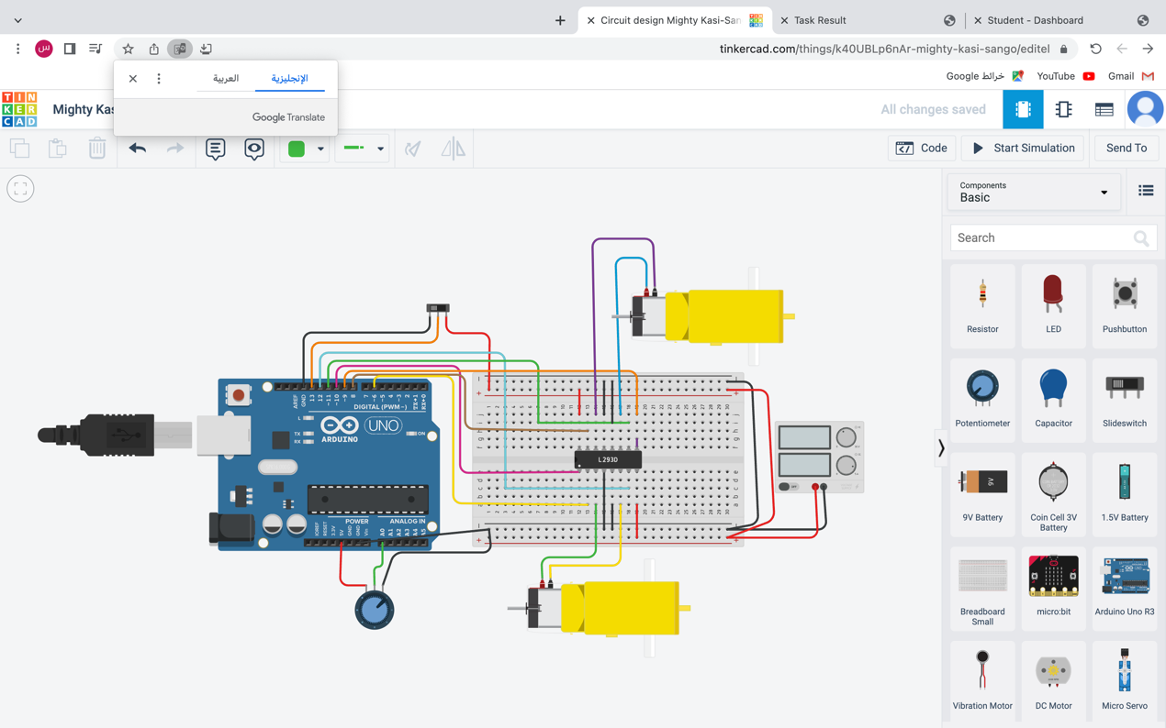

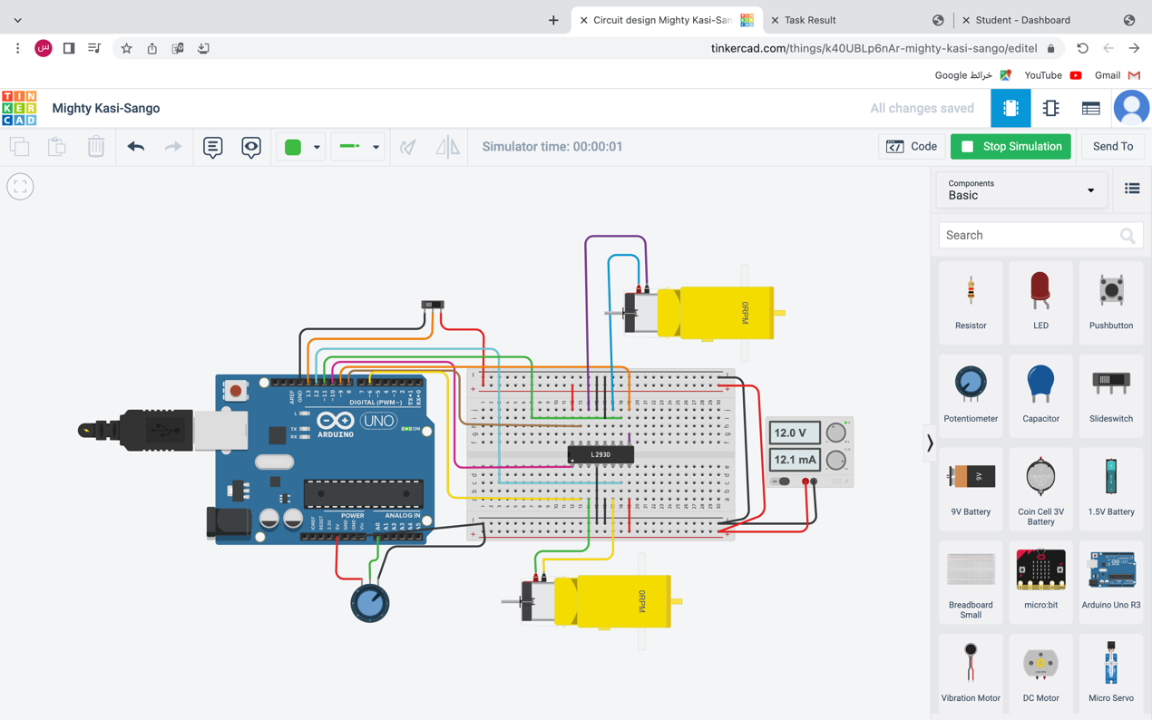

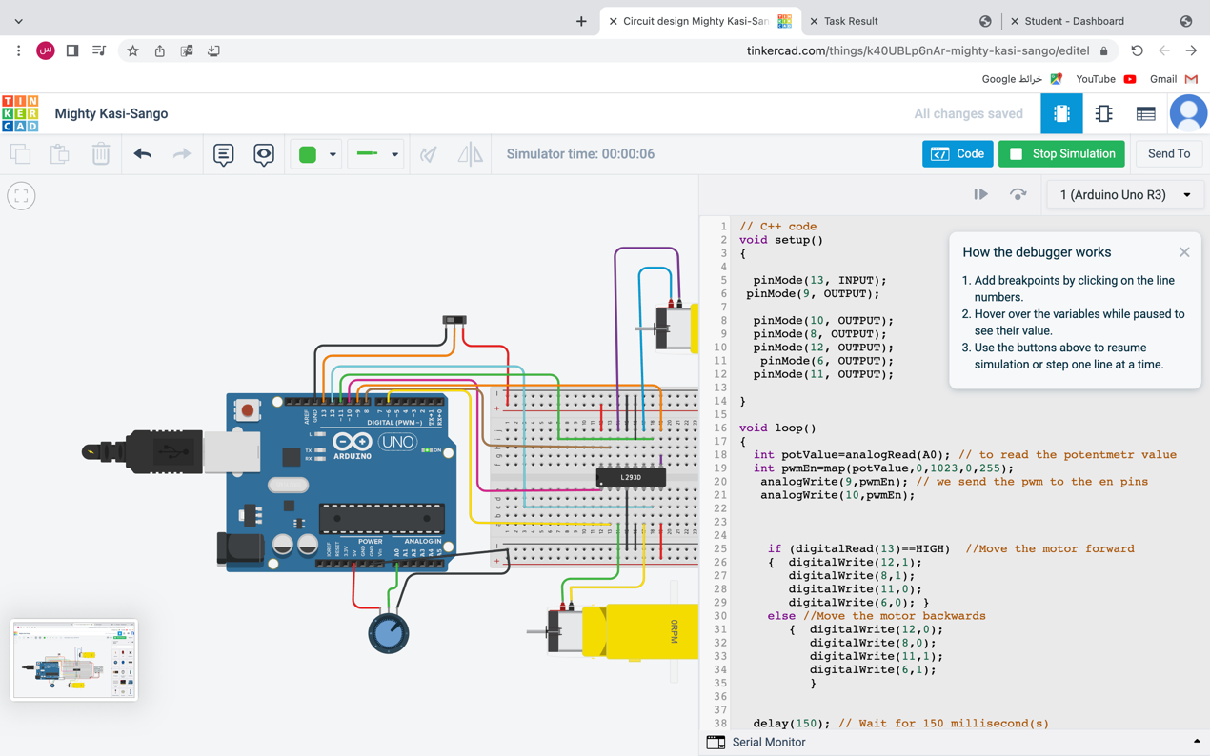

<https://www.tinkercad.com/things/k40UBLp6nAr>